**Project Proposal for PepLyna Ads Firm**

**Project Title:** PepLyna Ads Firm

PepLyna Team Details

|  |  |  |  |
| --- | --- | --- | --- |
| Name | Email | Mobile No | Role |
|  |  |  |  |
|  |  |  |  |
|  |  |  |  |
|  |  |  |  |
|  |  |  |  |
|  |  |  |  |
|  |  |  |  |
|  |  |  |  |
|  |  |  |  |
|  |  |  |  |

1. **Project Details:**

Project Title: PepLyna Ads Firm

Alternative Titles (if any): PepLyna Advertising Firm

Project Type: Cloud based software implementation

PepLyna Ads Firm is a web (cloud) based platform independent application which is localized in Sinhala language. Actually it not just an application, is a framework which helps users to create their advertisements, visiting cards and so on in Sinhala language. PepLyna Ads Firm works by connecting user’s browser to the cloud (Microsoft Azure) where the whole application is stored. User can use this from any platform (Windows, Linux, Mac and etc.) because it can cross platforms.User is not to worry to install any supporting applications on his/her personal computer .And also we are going to develop this to be used without adding of any plug to the user’s browser.

1. **The Goal and Objectives**

**Main Goal:**

Most of theSri Lankan users are not familiar with Sinhala letters (Especially in Sinhala typing) in computing. Although user is familiar with Sinhala letters, the supporting software for Sinhala alphabet are very few.

Creativity is the major factor to create any type of advertisement visiting cards and etc. But how many software from the above supporting tools (software) would enforce to create an advertisement in Sinhala creatively. So our main goal is to provide user a platform (framework) to build advertisements in Sinhala creatively and easily (Easily means to create advertisements in drag and drop manner rather than typing whole things from the outset).

**Objectives:**

Our objectives are listed below.

1. Provide cross platform (platform independent) software

The principal theory behind this application is cloud computing. So anyone can connect to the cloud from any platform (windows, Linux, Mac and etc.) and use this

2. To deliver very much user interactive (user friendly) application.

The application is expected to build with very user friendly GUIs. And the key to achieve the interactivity is building the software in drag and drop manners. User is able to add, delete, update and etc. the items easily.

3. Time and cost effectiveness

User will be able to save sessions and continue according to the free time. User should not worry to create whole advertisement at once.

It is desired to provide to options to provide cost effective software

1. for personal purposes

It is not charged by the user under this option. This provides sufficient tools to create personal stuffs for day today life. But user can’t feel the full experience.

1. Business(Commercial purposes)

User can use this package for the business purposes. A reasonable price us charged according to the tools (Components) are used by the user. Actually it is customizable.

1. **Tentative Problem Definition**

There are very few software exists which support to Sinhala alphabet to create advertisements. These tools don’t provide the factor creativity to create ads, visiting cards and etc. And the other problem is some of these tools require a very large memory capacity and processing power as well. The worst case is it is charged very higher price to activate these tools after expiring the given free trial.

But Product we are going to develop overcome these all issues and provides extra facilities with reference to usability and user friendliness as well to users.

1. Cloud based solution will solute the problem of requiring more memory and processing power.
2. Use of latest and smart word processing techniques will provide the creativity
3. Dragging and dropping will be making the product more user-friendly.
4. Providing two packages(options)-personal purpose and commercial purpose for the usage will make the product cost effective.
5. Combination of all above will make the application more usable and smarter.
6. **Brief introduction to the project**

**A. What is PepLyna Ads Firm….?**

**PepLyna Ads Firm** is a web (cloud) based application, but not just an application is a framework which helps users to create their advertisements, visiting cards and etc. in Sinhala. Advertising Firm works by connecting user’s browser to the cloud where the application is stored.

**B. What it does and what problems /issues are addressed ….?**

So far there is no any product is developed targeting the creation of Sinhala advertisements. Sri Lanka is a developing country and lot of people have started and are looking to start small, medium size businesses for the local market. So It is required a good marketing and promotion. For that they need good advertisements in Sinhala because it targets local market.

To create an advertisement, it is needed to go to an advertising firm. It is charged highly to create an advertisement by an advertising firm. And also it wastes time as well to create an ad by advertising firm. **PepLyna Ads Firm facilitates to create advertisements in Sinhala easily, cost effectively and creatively overcoming this problem**

In a business there are number of employees. So it is necessary to a have card (visiting card) for each employee. Some of cards should be created in Sinhala .So employer can create these cards without going to real adverting firm by using **PepLyna Ads Firm easily and creatively.**

**PepLyna Ads Firm also** provides education and entertainment for the users.

1. **Education**: Any one can learn the art of creating ads and visiting cards by using our software.it is provided a set of video tutorials which teach how to create advertisements, visiting cards and etc. Creatively.
2. **Entertainment** : user can try out and enjoy by creating different ads and visiting cards and etc.,

**C. Similar products Vs Uniqueness of the project**

It is not found any similar product or projects previously done for Sinhala alphabet (but can be found for English and some other languages). So it is crystal clear that the product is unique. Sri Lankan community will be embracing the product as soon it is released.

**D. Requirement gathering approaches**

**User Stories : -** It is expected to develop the product (implement the project) in an agile environment. Agile doesn’t very much supports for a user centric development. But user stories are a good technique can be used to gather requirements while overcoming this issue as well.

So it is desired to meet some local businessmen who possess small and large businesses in order to gather requirements. User stories are created by that manner. Their requirements are considered to design the system.

Gathering requirements will not be restricted to initial phase. It will be done throughout the development.

**E. How the system will be tested….?**

System is going to be developed in an agile context with number of sprints. At end of each sprint it is required to deliver some deliverables and meet some milestones. So project will be developed as an iterative prototype. After some certain sprints the product (the prototype) comes to a position where user can do some stuffs.

Then this working prototype is released to a group of selected users for feedbacks. Then the changes are made or redesign the system according to their feedbacks.

Unit testing are made by developers and integration, component, system and acceptance tests will be carried out by the aid of very powerful automated QA tool-Egg plant

1. **Technical Overview**

## Basic Architecture

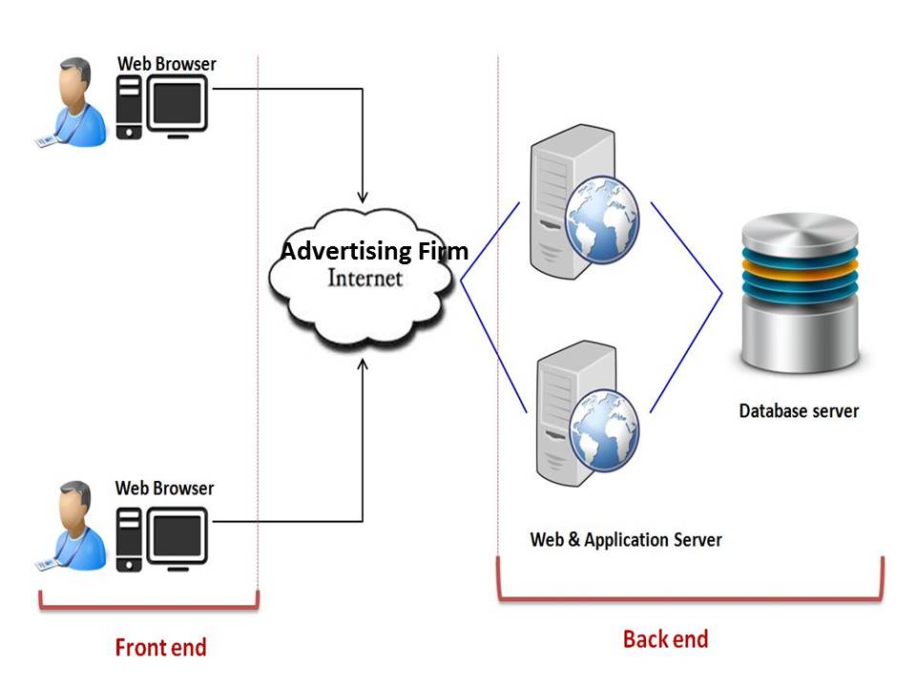

For Advertising Firm, it is used RESTful architecture. The complete application is installed on the cloud. Data resources are stored in a SQL database. User is restricted to access the database by using views. Views are created according to users’ needs. These views are fetched to the cloud as resources. User has to deal with only these resources. These resources can be used in JSON structure in client program.[The channel between cloud and users would be in JSON format in order to access resources]

In brief, this architectural model uses the HTTP standard to interact with objects. User creates new objects by using the HTTP PUT method. New object represents an advertisement or visiting card or etc. user is going to create. [Initially this object wouldn’t be null since it consists some basic data].User can delete those objects by using HTTP DELETE. This creates a standard interface for all objects, based on the HTTP standard. User can save these objects and continue work on these objects through any compatible browser (user should not worry to complete the whole work in his first session. He can save the object partially created and continue works in the next session)

## Architecture From developer’s perspective

The application is going to be built on Microsoft Azure Platform. For the First release, it is desired to buy “Platform as a service” (Paas) from Microsoft Cloud. It is shown below. (For the developer the application is seen as a platform as service)

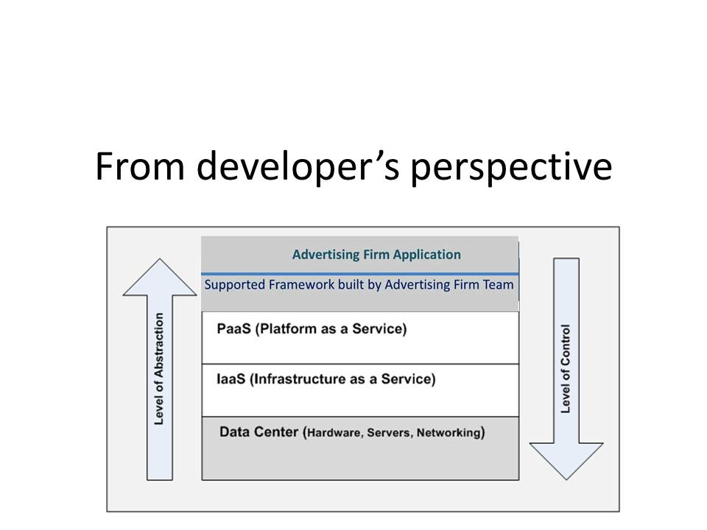

On the top of platform, a supported framework is built. This framework helps to manage resources very efficiently. It is expected to reduce difficulties which emerge during the development by using this framework.

The object which is created when initializing an Advertisement or visiting card includes data resources. These data resources are included in SQL database provided by Azure. Since it is bought only the platform, it is impossible to scale/extend the database storage.

**Front end Architecture and Customer Perspective**

Customer sees everything on his PC. Browser does this part for customer. Browser works as the front end of this distributed application. It is desired to be built this web based application to be compatible with Firefox, Chrome and IE without the need of any additional plug-ins.

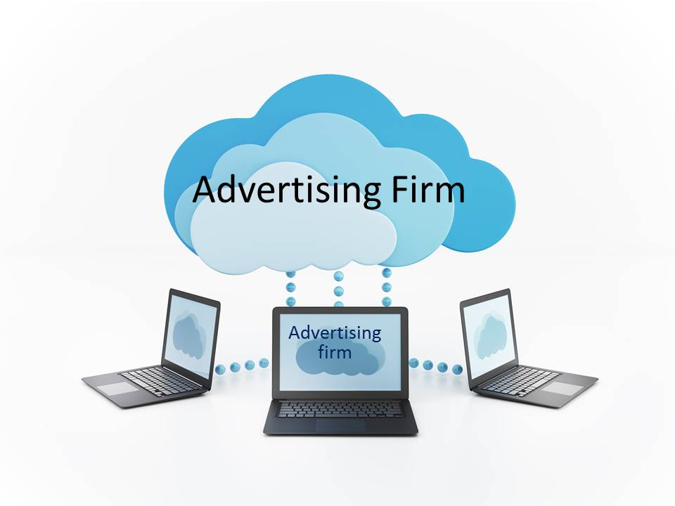

For the end user the app is shown as a “software as a service on cloud”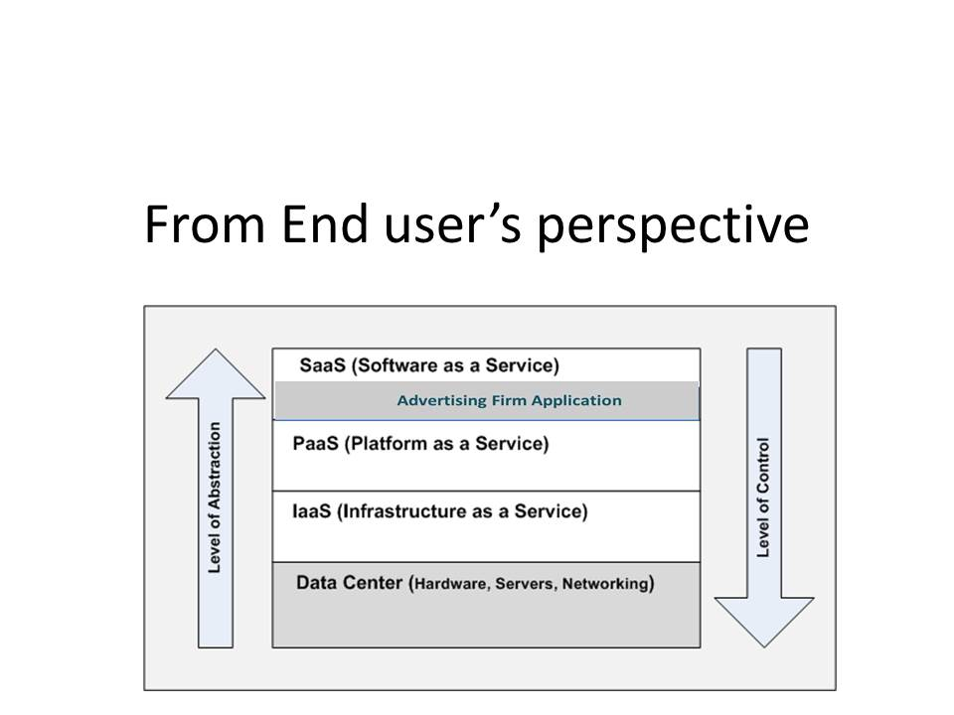

**Security**

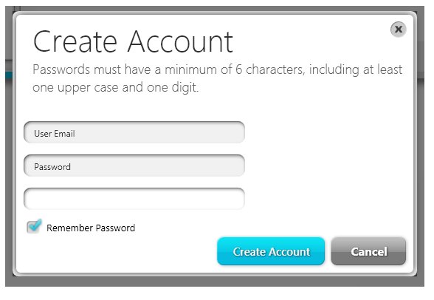The end user should have an account in order to get this cloud service. The account is created on his Email address. He should provide an email address and password to create this account. Then advertising firm team sends a confirmed email to the given email. This is a verification email for the end user. Once he verified, the account is created. Then he can login with that account and continue works.

Only one account can be created by one email address.

This helps to prevent robots using cloud resources (prevent from robot attacks).

1. **The scope of the System**
2. **Target users**

The main target users are the owner and management of small and medium size local businesses. Other than that anyone who is in a need to create advertisement or visiting card is addressed.

1. **Technologies hoping to use**
   * Cloud technologies introduced by Microsoft-Azure SDk
   * Word processing technologies
   * Image processing technologies
   * MVC architecture based technologies
   * Technologies for web based applications (java script and asp.net based)
2. **Main functionalities**

For the first release following functions will be addressed. User is able to perform following functions and hope to add more functions and features to next release.

* Creating an advertisement in Sinhala

User should login to system under either personal or commercial package and create an advertisement in Sinhala and English.

* Creating an visiting card in Sinhala and English

User should login. But it is not required a select any package since this service is free for any registered user. User is facilitated to create a visiting card in Sinhala

1. **Users (possible actors) of the system**

After installing the system on cloud user can use it (perform functions mention above) alone. System itself will facilitates to be used it without the help some other party. Verifications will be done automatically and emails will be generated and sent automatically.

But user should contact and inform system administrators or maintaining team in a case of

* System failure
* Unpredictable and unexpected behavior and etc.

1. **Nonfunctional requirements**

* **Reliability:** A key requirement hope to achieve since the system is web based and depends on network connection. MTTF (mean time to failure) is also considered under this section.
* **User Friendliness**
* **Usability**
* **Availability:** since the system is on cloud availability will highly effect on its users

1. **Resource requirements**

**Word processing and image processing resources:**

The product is completely depending on the image and word processing it is required word and image processing components. It is desired develop some of them by the team and buy the rest from market.

**Cloud and Database resources:**

These resources are bought from Microsoft. Cloud space is desired to bring as virtual machine and database will resides on that.

1. **Limitations**
   * The system is localized in to Sinhala and English alphabet. User can’t use other alphabets and there are limitations on the symbols user need to use.
   * Since the system is installed on cloud there would be performance problems when traffic is very high
2. **The deliverables of the system**

It is expected to deliver a system which is installed on cloud .All specified function will be working properly as specified in the final product.

And also it will provide series of video tutorials by which user can learn how to create an advertisement creatively.

* **Targeted users of the product** :
* Management and the owners of small and medium size business
* People who need to create an advertisement for their personal purposes
* **Functions in the product that address targeted users :**

It creates an advertisement using Sinhala and English alphabet and it creates visiting card in both alphabet

* **Scalability and expandability of the product:**

The system is localized in to only Sinhala for first release.it is expected to release it for other languages in next releases and it is desired to add the functionality to create certificates like things.

* **Features/functions in the product that empower users to accomplish their tasks easily**
* The user is provided a user manual as a PDF or HTML page. It will help to user to understand the system and clarify any conflicts addresses in the system.
* The system provides very user friendly GUIs and user will meet drag and drop environment. This will make the product more user-friendly.
* System manual is also provided
* User documentations and system documentations
* **Compatibility and interoperability with the other systems in the market**

There is no any similar system found which is localized in Sinhala. So this is going to be unique.

* **Security features in the product**

User need to register (create an account) in order to work on this. So the things done by the user in his/her account are only visible to user his/himself. No one can see or stole an advertisement made by another user.

* **Features/functions in the product that addresses/ relate to product maintenance**

It is required to clean databases once a month. In this process the advertisement which are completely created (finished) and used are removed with Corresponding database entries

* How the quality of the software to be tested together with the latest technologies

The software is tested by very powerful automated testing tool called “Eggplant” and deploy to users

1. **The Project Plan**

**//this part will be done by rangana**

1. **References**

Virtual Machines Documentation | Azure

azure.microsoft.com/en-us/documentation/services/virtual-machines

[Accessesed: 13th September 2014]

Microsoft's Azure cloud platform: A guide for the perplexed

http://www.zdnet.com/blog/microsoft/microsofts-azure-cloud-platform-a-guide-for-the-perplexed/1671

[Accessesed: 14th September 2014]

Learn ASP.NET MVC Programming using C#

www.c-sharpcorner.com/1/226/asp-net-mvc.aspx

[Accessesed: 13th September 2014]

Image Processing Lab in C#

<http://www.codeproject.com/Articles/9727/Image-Processing-Lab-in-C>

[Accessesed: 12th September 2014]

C# Word - Process Word Document in C#

<http://www.rasteredge.com/how-to/csharp-imaging/word-processing/>

[Accessesed: 15th September 2014]